Mid-Work-Term

Co-op Student Performance Evaluation

STUDENT VERSION 1.0

Student Name:
Student Number:
Employer:
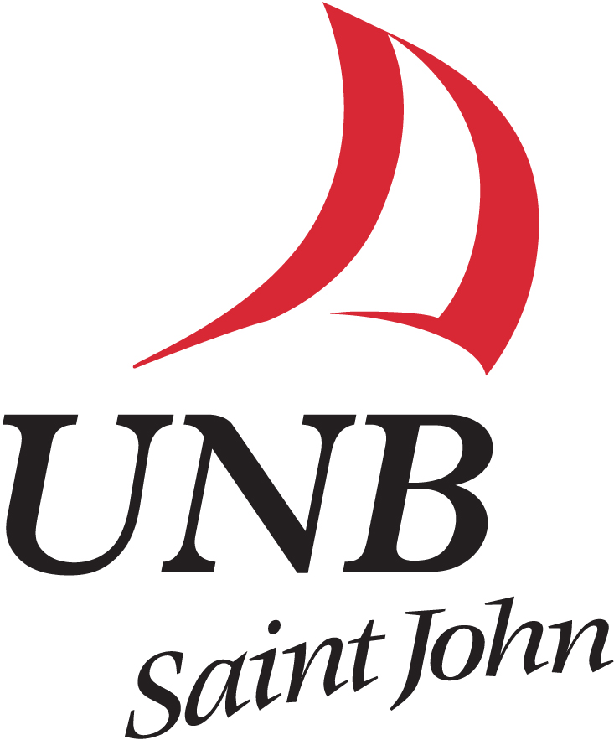

This form is to be completed and reviewed with your supervisor. Once completed, all forms are to be forwarded to the co-op office before the due date listed below.

Due Date: Click here to enter a date.

The Co-op Student Evaluation Form outlines standards of job performance, complete with descriptions of each possible grade. Consider your current degree of performance in each area of work, and evaluate accordingly. Mark the box corresponding with the grade you feel best represents your performance.

The scale is defined as follows:

Requires Improvement: Fails to meet standards, or meets them only in part. Performance is below expectations. Improvement is needed.

Meets Expectations: Meets the standards of the position satisfactorily. Performance aligns with the average.

Exceeds Expectations: Meets or exceeds standards. Performance is clearly above average.

N/A: Not Applicable

If a dimension does not apply to your current employment situation, please mark the box titled “N/A.” A comment section has been included so that you may provide a brief explanation of your declared grade.

It is possible that you and your supervisor perceive your performance differently. To prevent complications, please discuss any discrepancies with your supervisor before you each forward completed forms to the co-op office.
- Accuracy: the precision of duties performed
Requires Improvement | Meets Expectations | Exceeds Expectations | N/A
Comments:

- Adaptability: a positive attitude towards change and the ability to change easily to fit different conditions
Requires Improvement | Meets Expectations | Exceeds Expectations | N/A
Comments:

- Assertiveness: the ability to express ideas and thoughts directly and honestly without offending or being inconsiderate to the other party
Requires Improvement | Meets Expectations | Exceeds Expectations | N/A
Comments:

- Computer Literacy: the ability to effectively use the computer systems available in the workplace
Requires Improvement | Meets Expectations | Exceeds Expectations | N/A
Comments:

- Creativeness: the ability to identify and suggest new ideas to get the job done
Requires Improvement | Meets Expectations | Exceeds Expectations | N/A

Comments:

- Communication:
Oral: effective speaking and listening
Requires Improvement | Meets Expectations | Exceeds Expectations | N/A
Written: effective reading and writing
Requires Improvement | Meets Expectations | Exceeds Expectations | N/A

Comments:

- Interpersonal Skills: the ability to get along with and help others, to recognize and respect people’s diversity and individual differences
Requires Improvement | Meets Expectations | Exceeds Expectations | N/A

Comments:

- Pro-activity: the ability to perceive and carry out required tasks without supervision and to anticipate the organization’s needs
Requires Improvement | Meets Expectations | Exceeds Expectations | N/A

Comments:

- Productivity: the ability to produce the desired results
Requires Improvement | Meets Expectations | Exceeds Expectations | N/A

Comments:

- Reasoning: the ability to think critically and logically to evaluate situations, solve problems and make decisions
Requires Improvement | Meets Expectations | Exceeds Expectations | N/A

Comments:

- Responsibility: the accountability for actions taken
Requires Improvement | Meets Expectations | Exceeds Expectations | N/A

Comments:

- Self Confidence: the belief in ones’ own ability, power, and judgement
Requires Improvement | Meets Expectations | Exceeds Expectations | N/A

Comments:

- Teamwork: the ability to understand and work within the culture of the group
Requires Improvement | Meets Expectations | Exceeds Expectations | N/A

Comments:

- Time Management: the ability to manage time effectively so as to complete assigned tasks and meet deadlines
Requires Improvement | Meets Expectations | Exceeds Expectations | N/A

Comments:

- Work Interest: responsibilities are performed with diligence and enthusiasm
Requires Improvement | Meets Expectations | Exceeds Expectations | N/A

Comments:

Attendance
Meets organizational standards
Does not meet organizational requirements

Work Term Report Type: Choose an item.
Work Term Report Topic:
Topic has been approved by supervisor

Additional Comments:

________________________________ ________________________________
Student’s Signature Date
________________________________ ________________________________
Supervisors’ Signature Date
________________________________ ________________________________
Coordinator’s Signature Date

