Yvonne Simpson’s Power Point Presentation (PPT) – Companion word document for accessibility purposes
A condensed version of each PPT slide is provided. The PPT slide number and contents of each slide are outlined below each condensed slide.
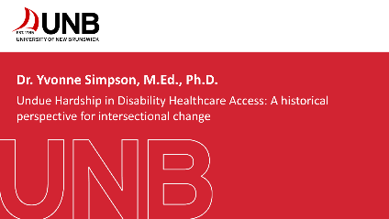
- Title Slide
Logo UNB
Dr. Yvonne Simpson M.Ed., Ph.D.
UNB

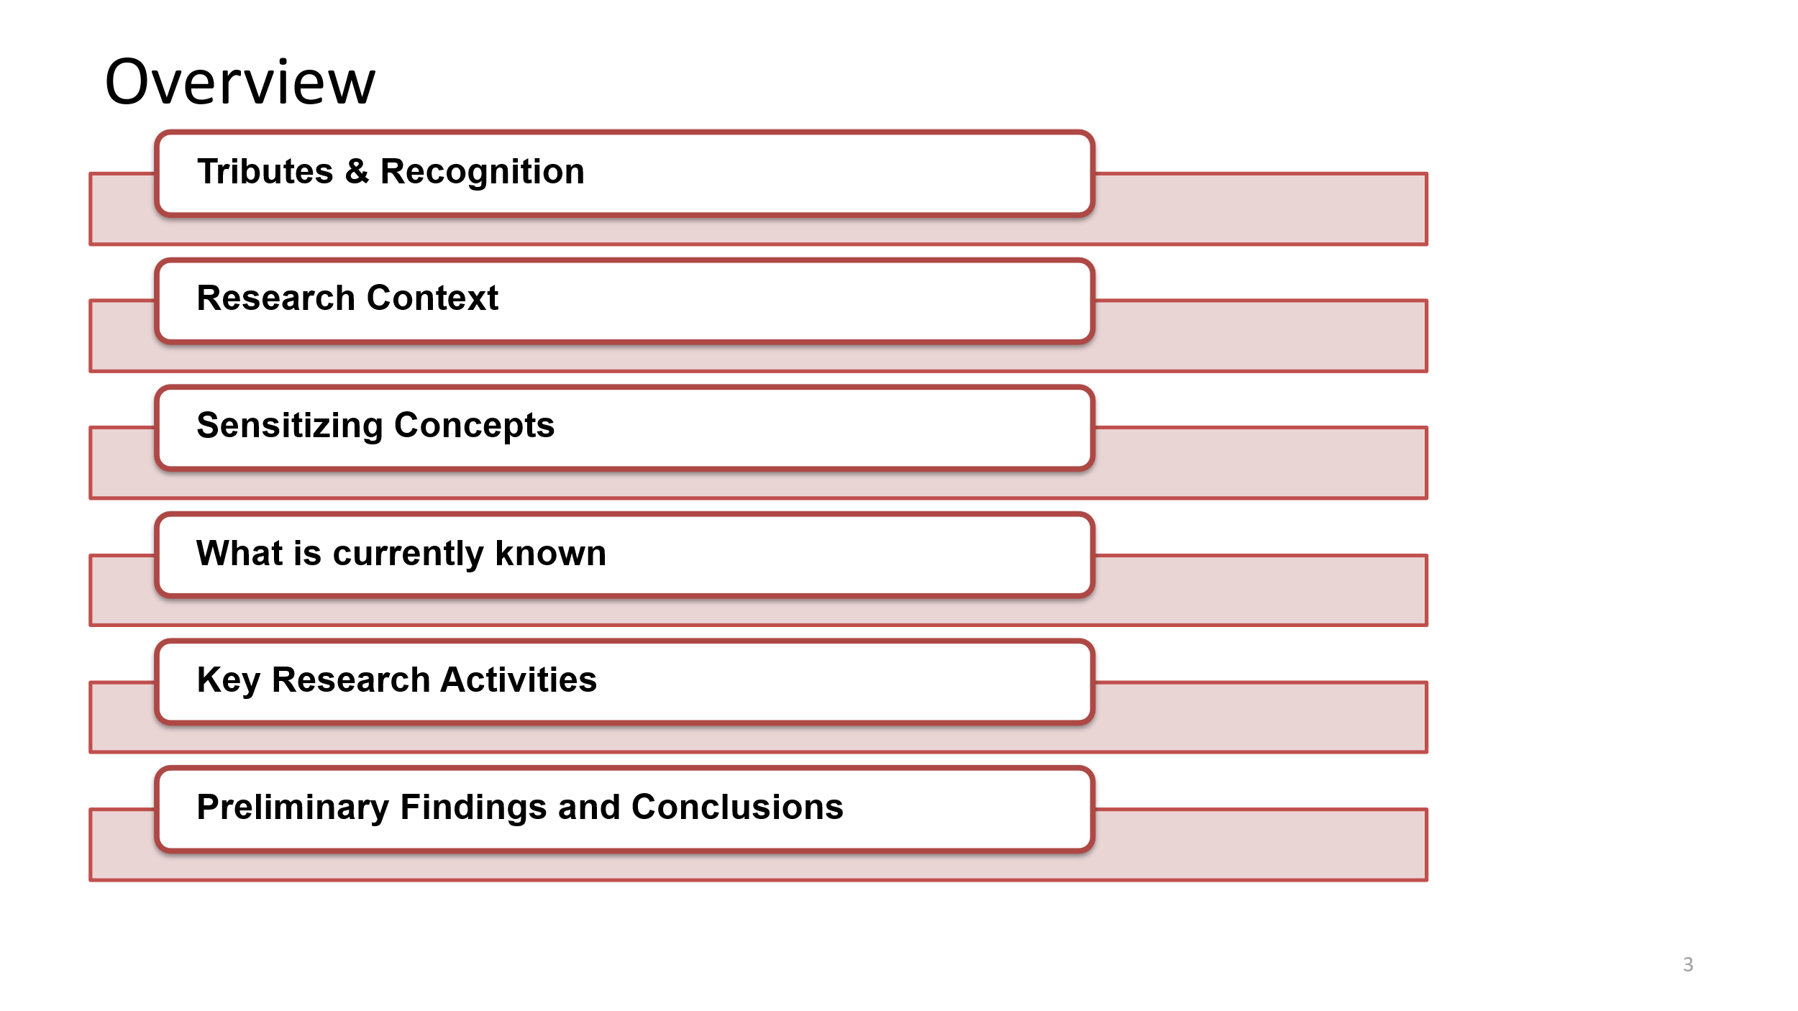
- Overview
Tribute & Recognition
Research Context
Sensitizing Concepts
What is currently known
Key Research Activities
Preliminary Findings and Conclusions
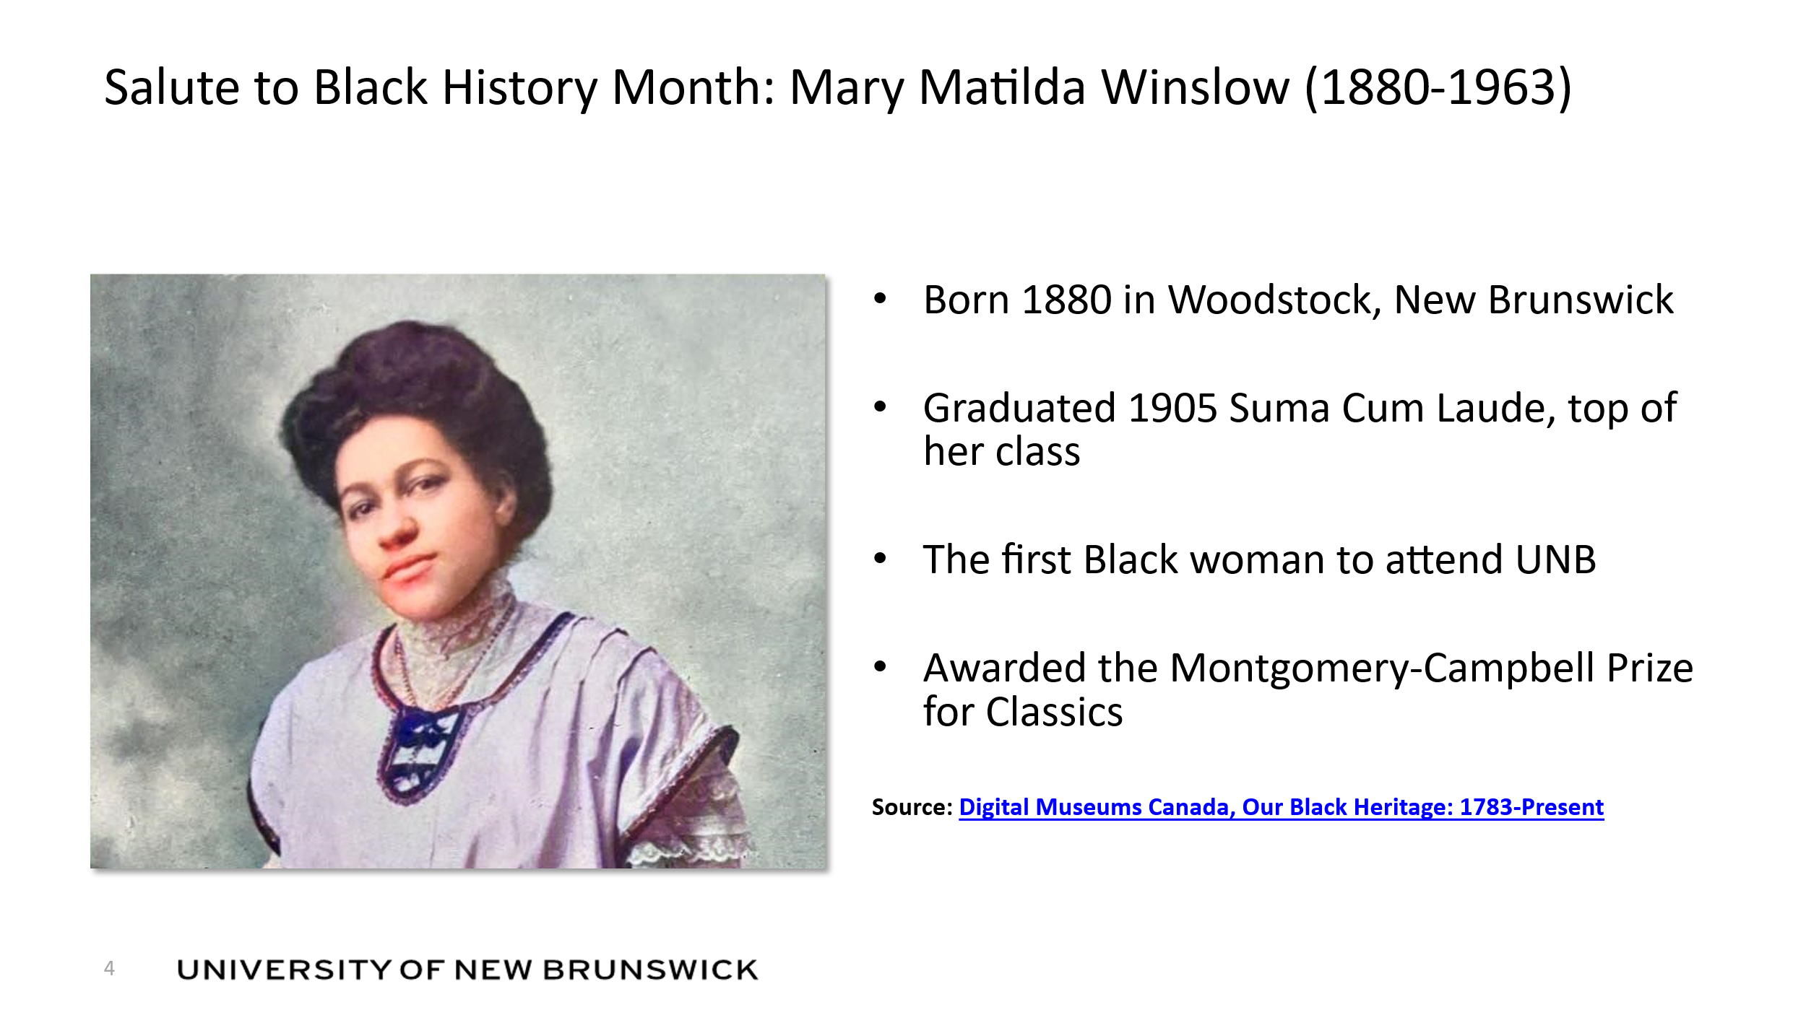
- Salute to Black History Month: Mary Matilda Winslow (1880-1963)
Photo image of Mary Matilda Winslow (1880-1963
Born 1880 in Woodstock, New Brunswick
Graduated 1905 Suma Cum Laude, top of her class
The first Black woman to attend UNB
Awarded the Montgomery-Campbell Prize for Classics
Source Link: Digital Museums Canada, Our Black Heritage: 1783-Present

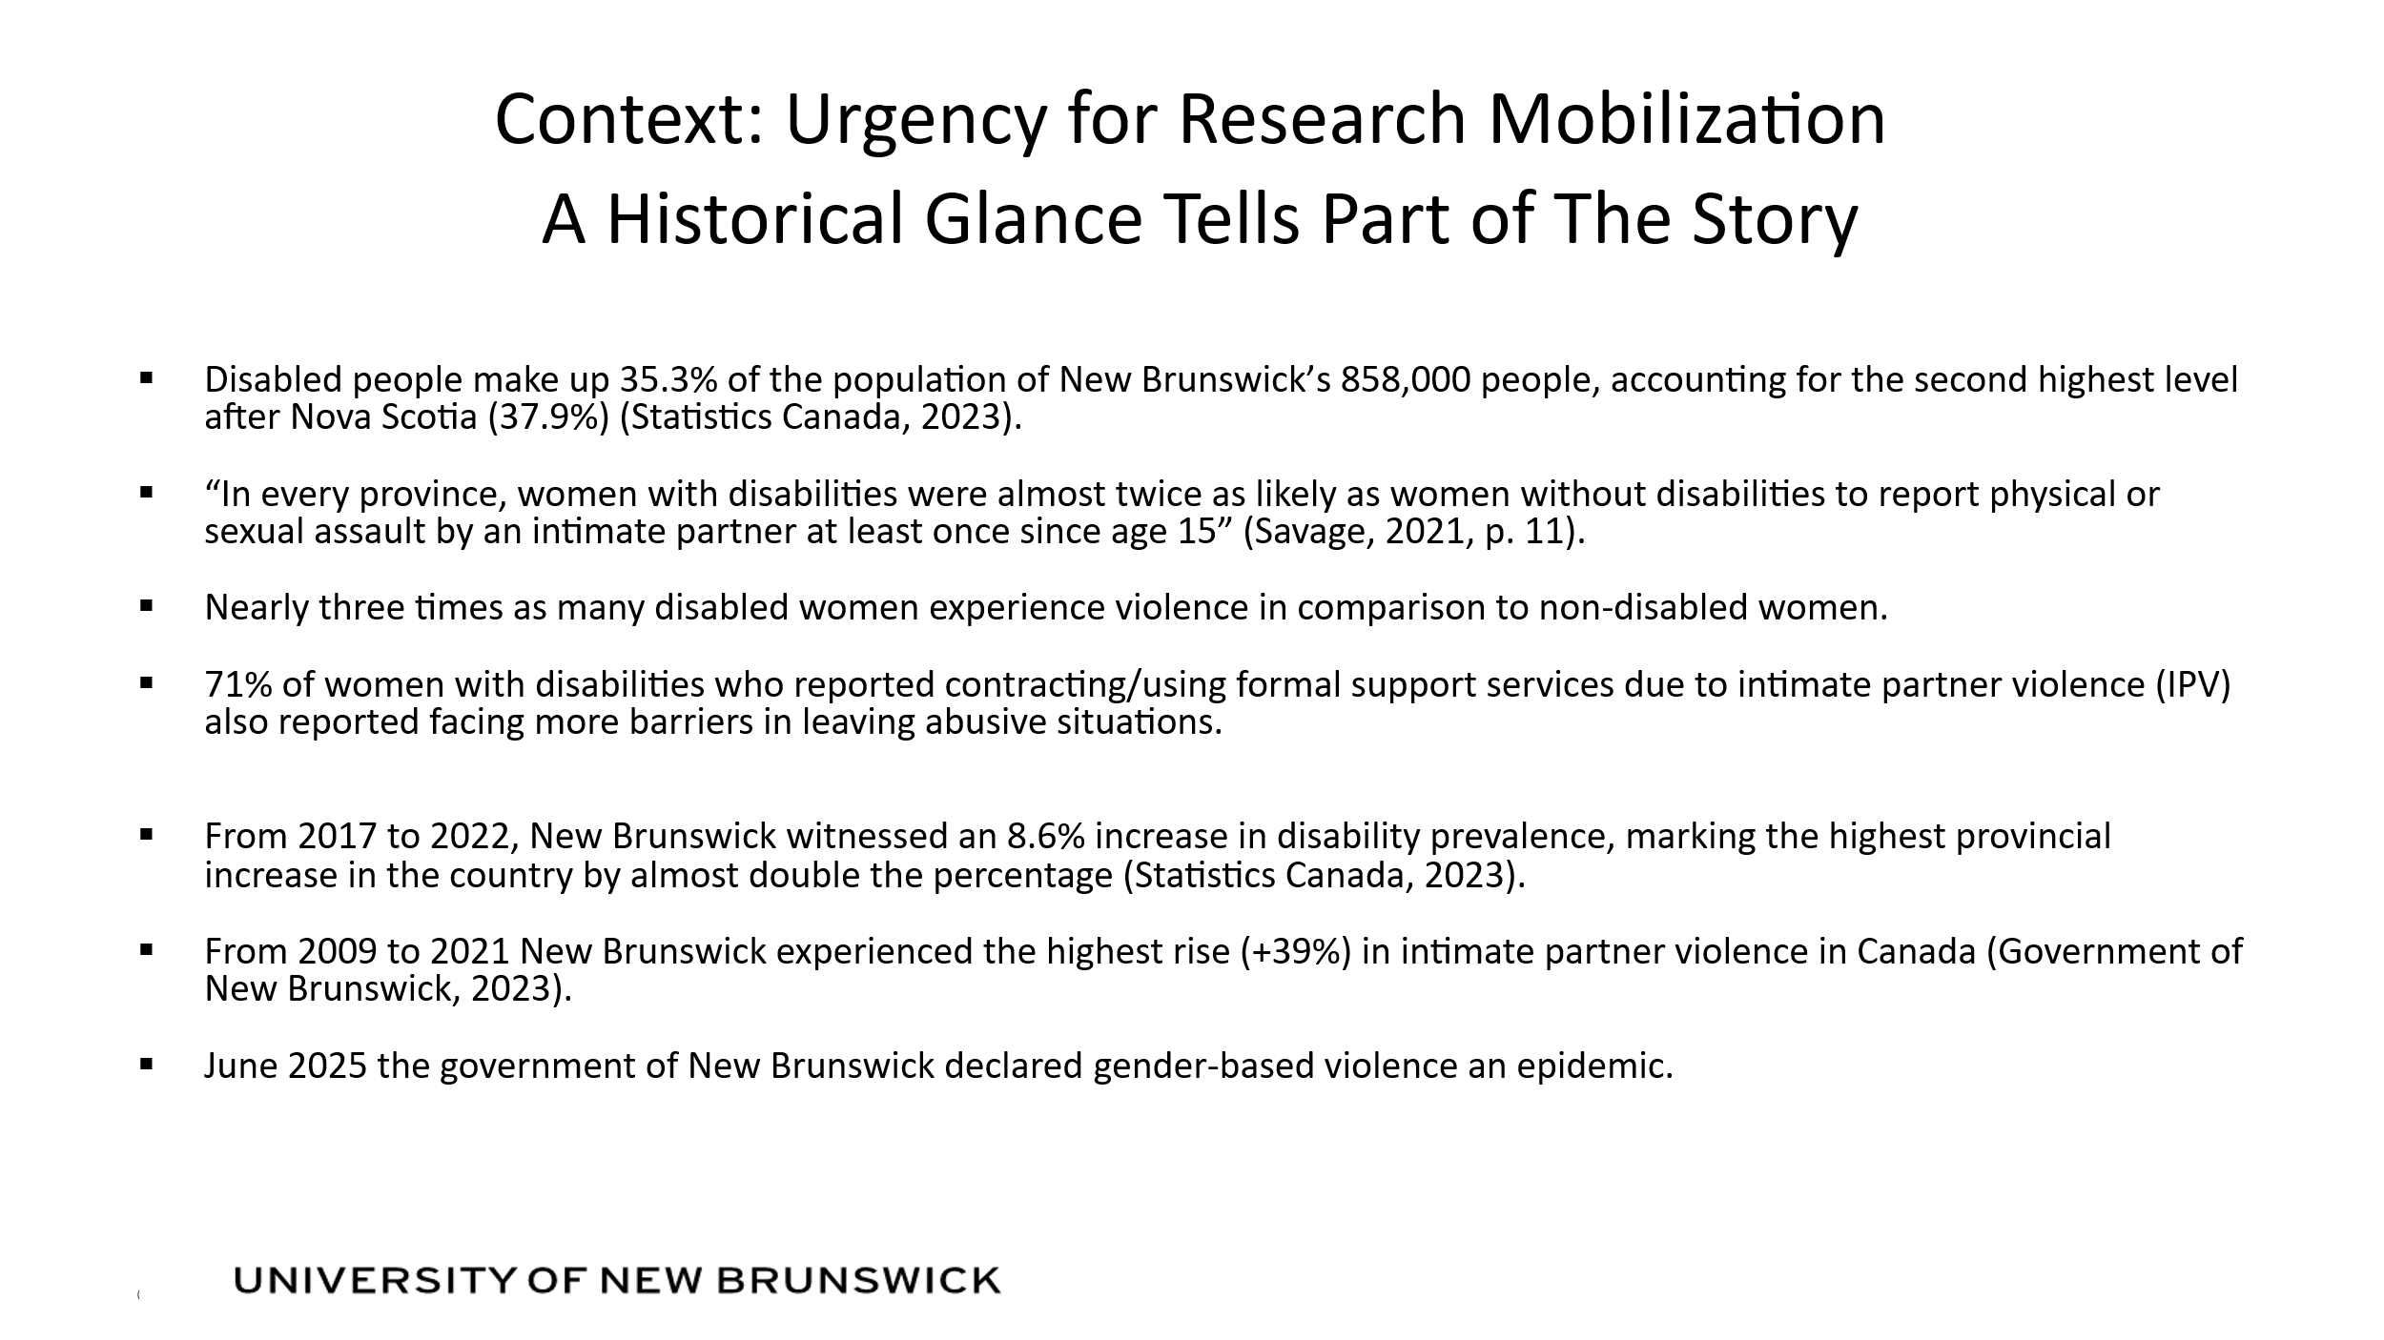

- Context: Urgency for Research Mobilization A Historical Glance Tells Part of the Story
Disabled people make up 35.3% of the population of New Brunswick’s 858,000 people, accounting for the second highest level after Nova Scotia (37.9%) (Statistics Canada, 2023).
“In every province, women with disabilities were almost twice as likely as women without disabilities to report physical or sexual assault by an intimate partner at least once since age 15” (Savage, 2021, p. 11).
Nearly three times as many disabled women experience violence in comparison to non-disabled women.
71% of women with disabilities who reported contracting/using formal support services due to intimate partner violence (IPV) also reported facing more barriers in leaving abusive situations.
From 2017 to 2022, New Brunswick witnessed an 8.6% increase in disability prevalence, marking the highest provincial increase in the country by almost double the percentage (Statistics Canada, 2023).
From 2009 to 2021 New Brunswick experienced the highest rise (+39%) in intimate partner violence in Canada (Government of New Brunswick, 2023).
June 2025 the government of New Brunswick declared gender-based violence an epidemic.

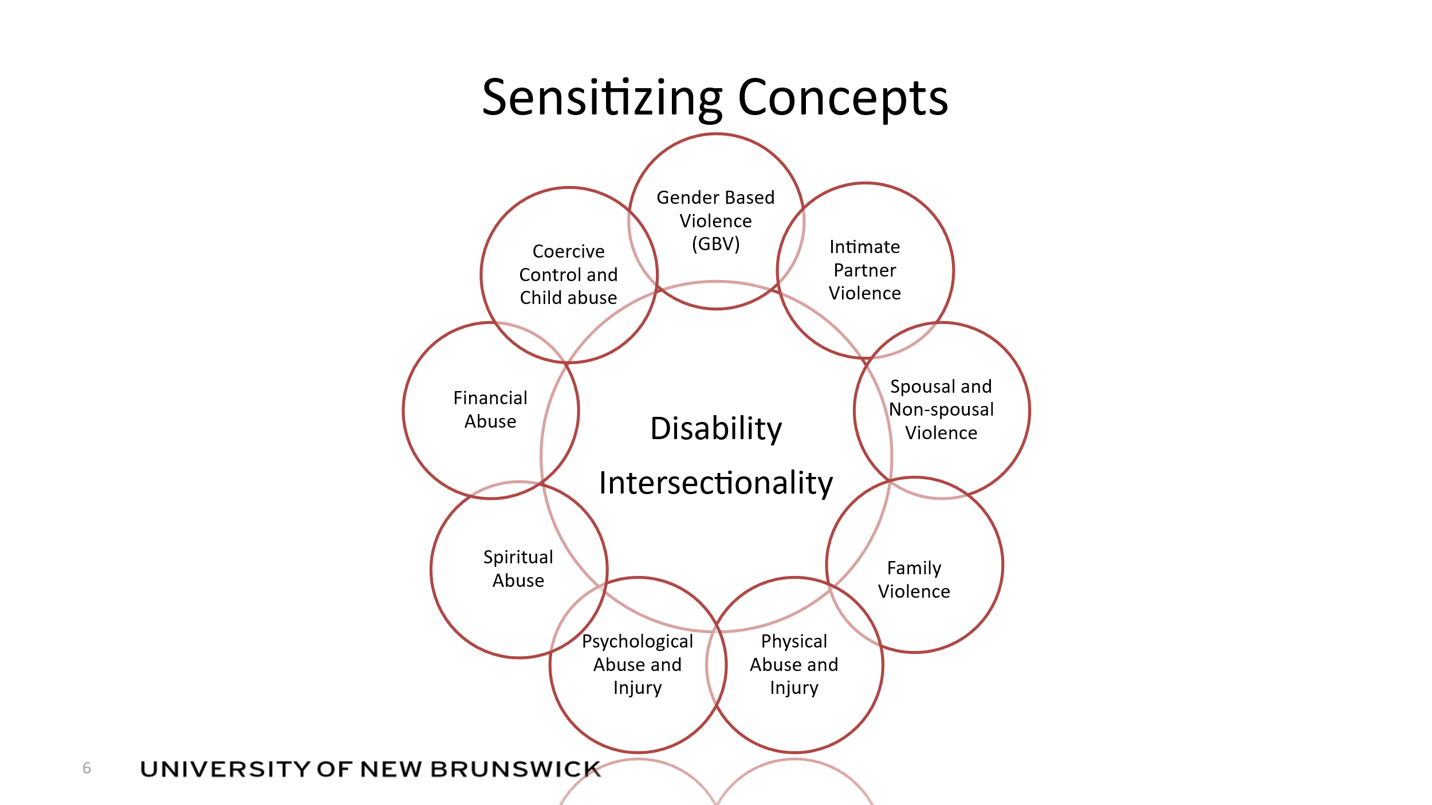

- Sensitizing Concepts
Information provided in a cycle graphic as follows:
Gender Based Violence (GBV)
Intimate Partner Violence
Spousal and Non-spousal Violence
Family Violence
Physical abuse and injury
Psychological Abuse and Injury
Spiritual Abuse
Financial Abuse
Coercive Control and Child Abuse

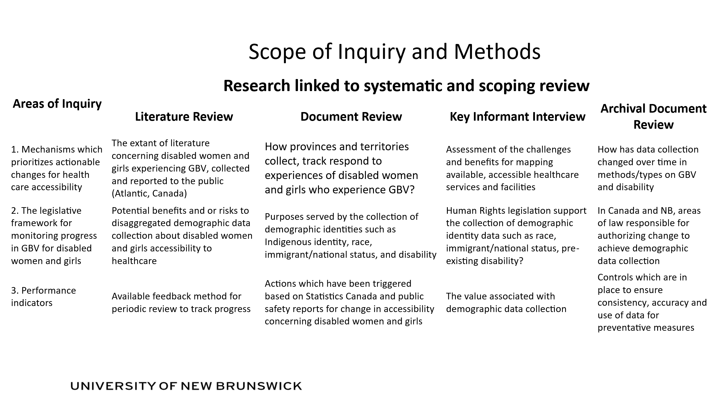
- Scope of Inquiry and Methods

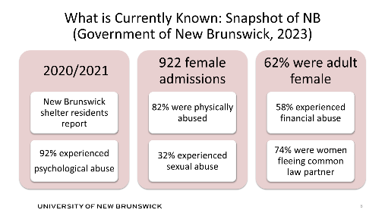

- What is Currently Known: Snapshot of NB (Government of New Brunswick, 2023)
This is a table which outlines the following
2020/2021
New Brunswick shelter residents report
92% experienced psychological abuse

922 female admissions
82% were physically abused
32% experienced sexual abuse

62% were adult female
58% experienced financial abuse
74% were women fleeing common law partner

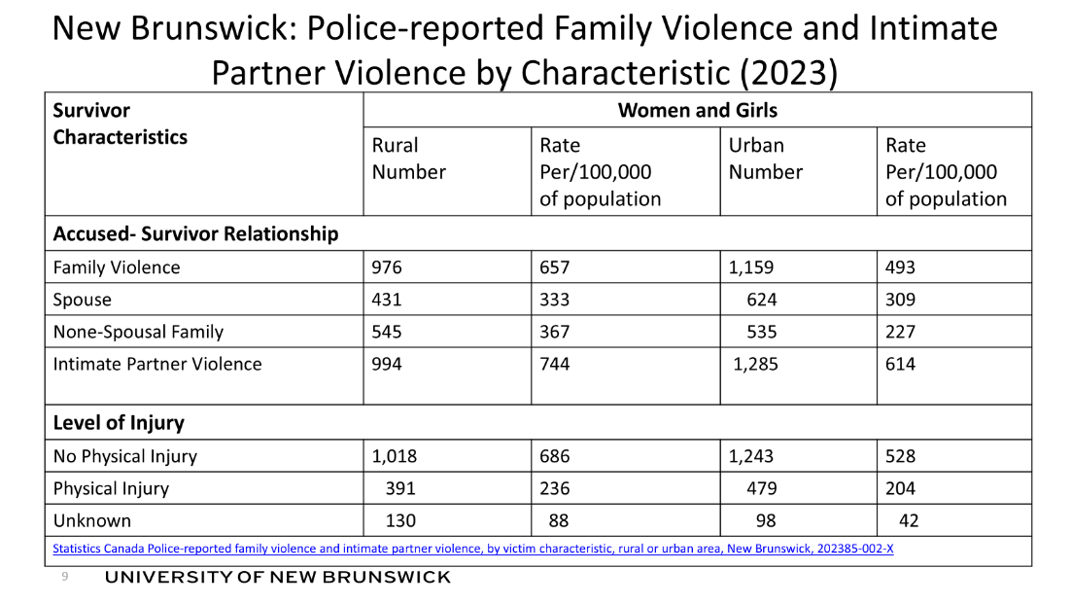
- New Brunswick: Police-reported Family Violence and Intimate Partner Violence by Characteristic (2023)
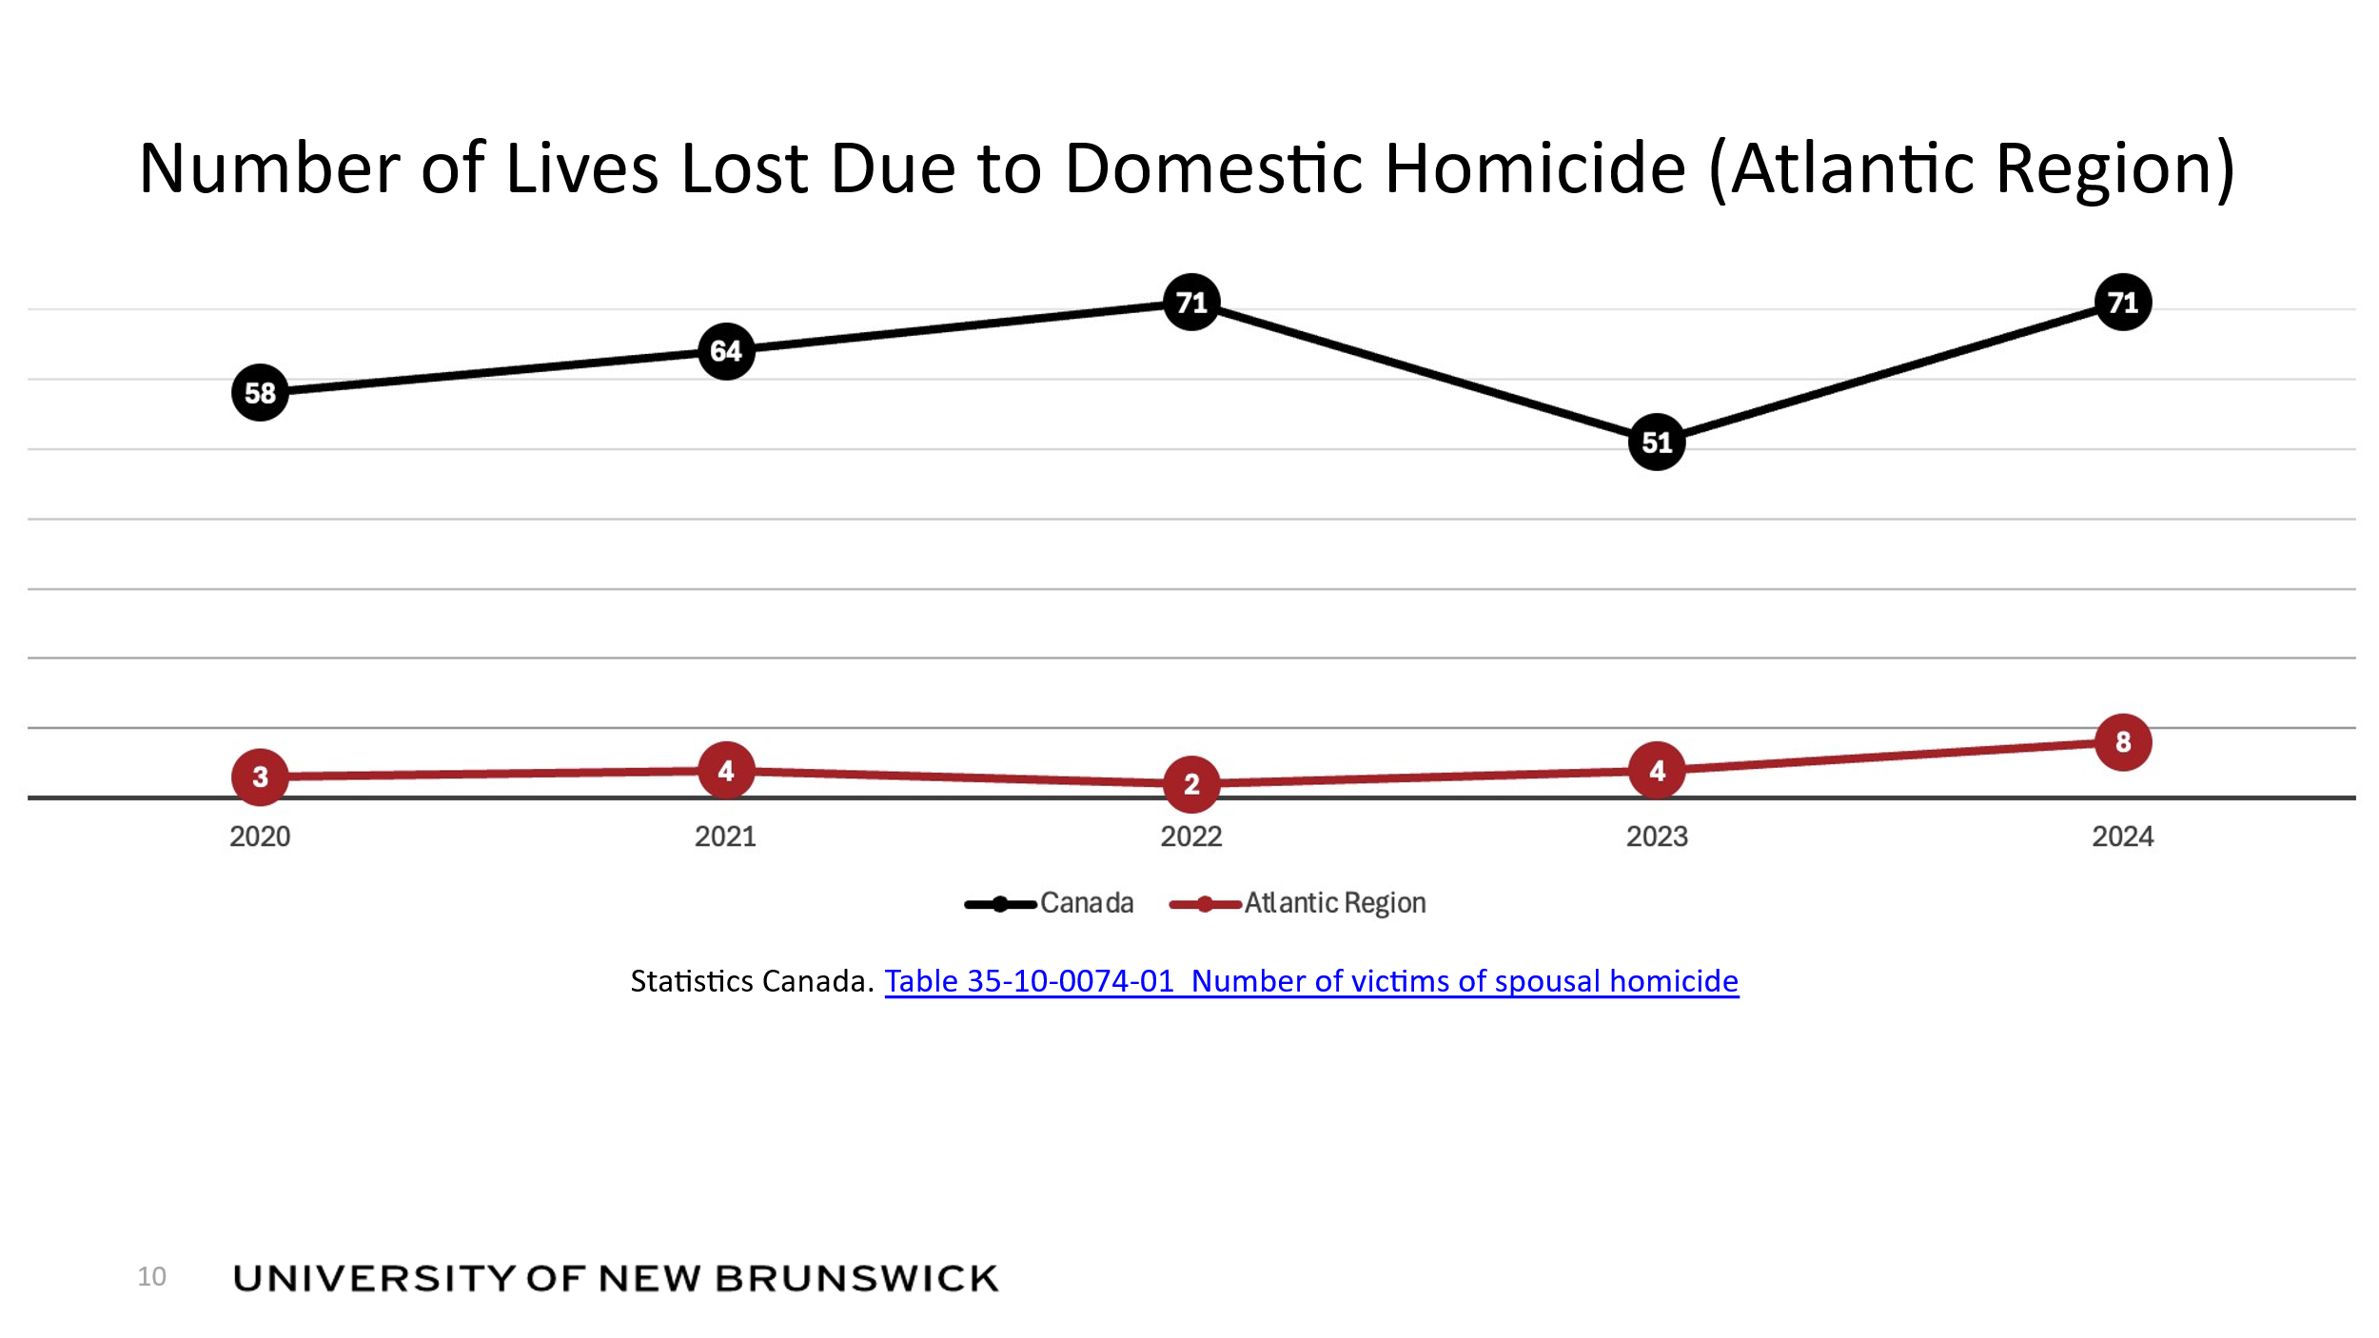
- Number of Lives Lost Due to Domestic Homicide (Atlantic Region)
Canada: 2020=58 2021=64 2022=71 2023=51 2024=71
Atlantic Region: 2020=3 2021=4 2022=2 2023=4 2025=8
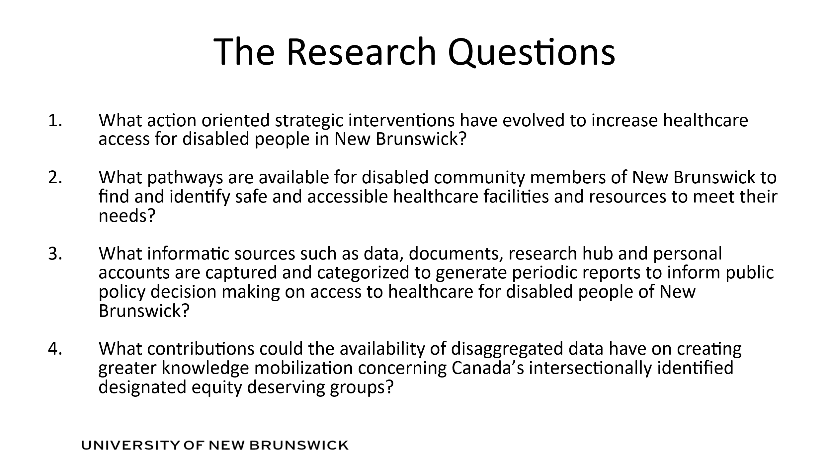
- The Research Questions
- What action oriented strategic interventions have evolved to increase healthcare access for disabled people in New Brunswick?
- What pathways are available for disabled community members of New Brunswick to find and identify safe and accessible healthcare facilities and resources to meet their needs?
- What informatic sources such as data, documents, research hub and personal accounts are captured and categorized to generate periodic reports to inform public policy decision making on access to healthcare for disabled people of New Brunswick?
- What contributions could the availability of disaggregated data have on creating greater knowledge mobilization concerning Canada’s intersectionally identified designated equity deserving groups?

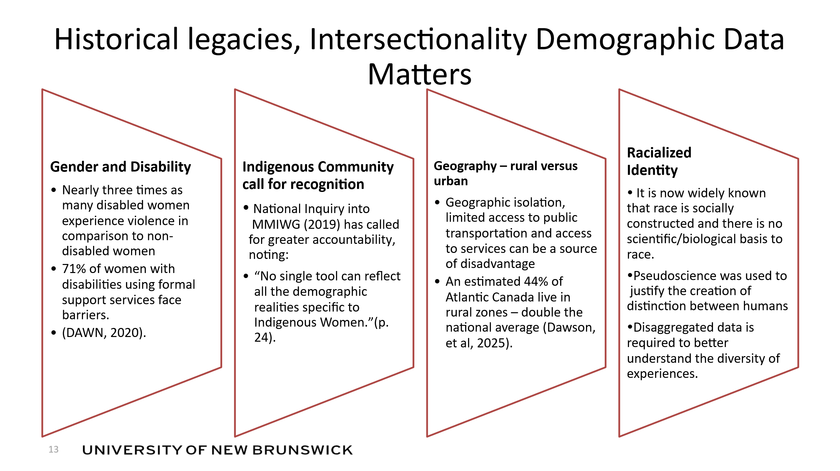
- Historical legacies, Intersectionality Demographic Data
Information is set in a four box graphic design. Contents of each box is as follows:
Gender and Disability
Nearly three times as many disabled women experience violence in comparison to non-disabled women
71% of women with disabilities using formal support services face barriers. (DAWN, 2020).

Indigenous Community call for recognition
National Inquiry into MMIWG (2019) has called for greater accountability,
noting: “No single tool can reflect all the demographic realities specific to Indigenous Women.”(p. 24).

Geography – rural versus urban
Geographic isolation, limited access to public transportation and access to services can be a source of disadvantage
An estimated 44% of Atlantic Canada live in rural zones – double the national average (Dawson, et al, 2025).

Racialized Identity
It is now widely known that race is socially constructed and there is no scientific/biological basis to race.
Pseudoscience was used to justify the creation of distinction between humans
Disaggregated data is required to better understand the diversity of experiences.

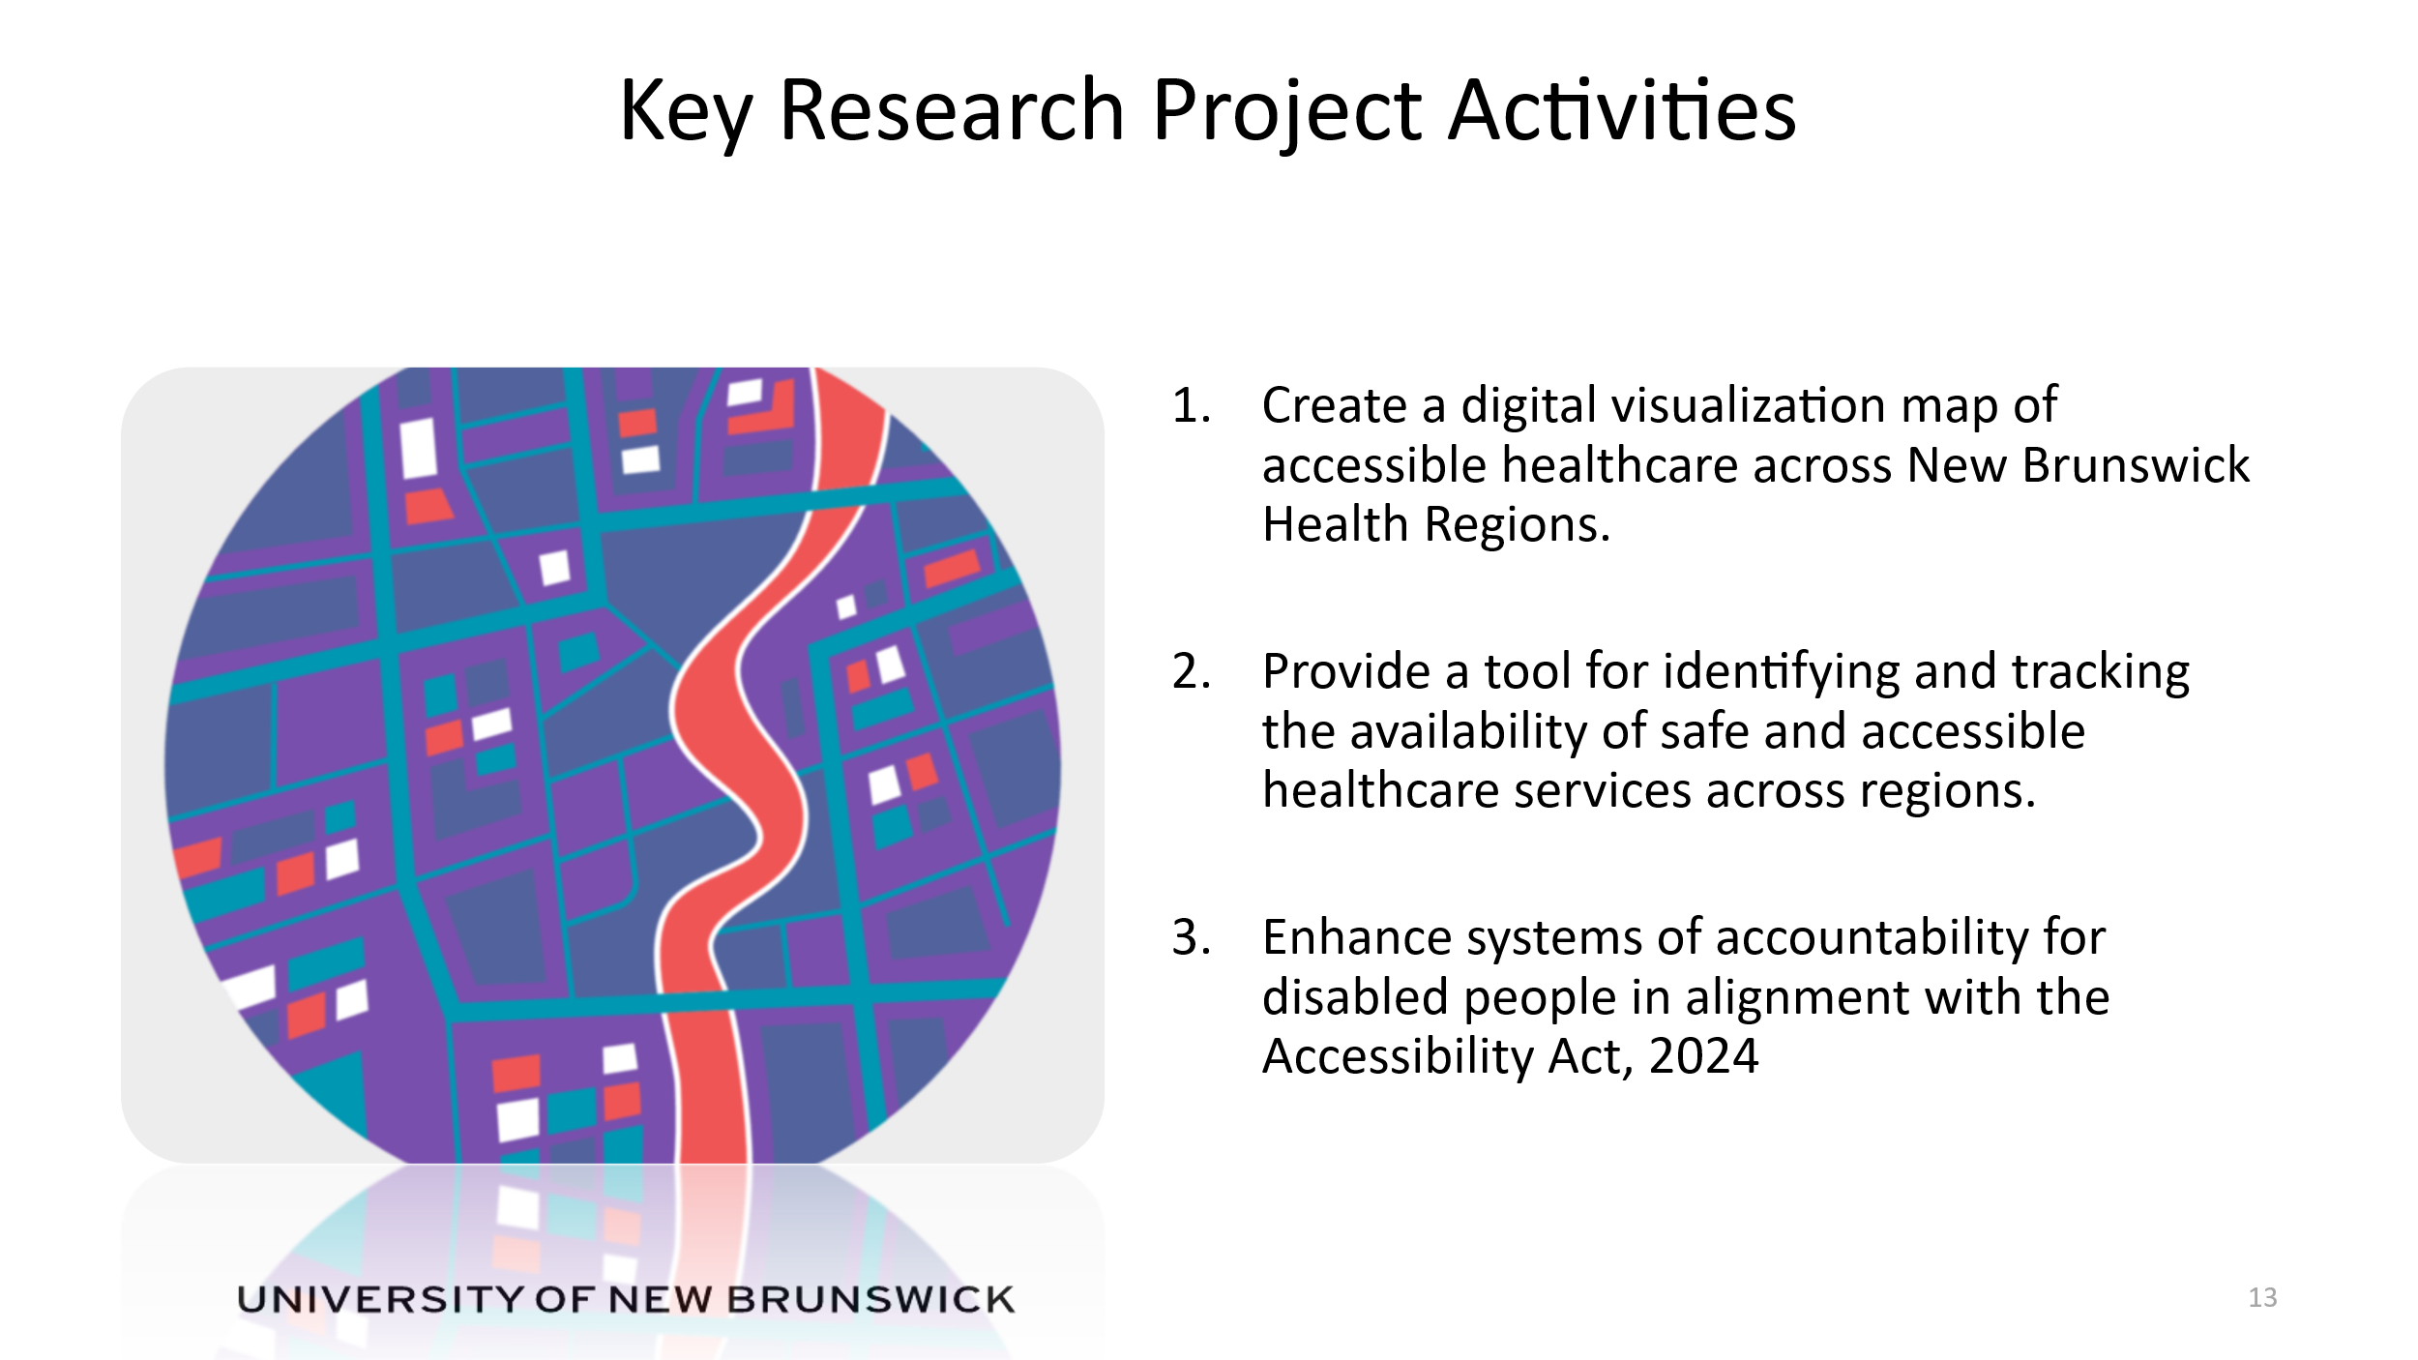
- Key Research Project Activities
Create a digital visualization map of accessible healthcare across New Brunswick Health Regions.
Provide a tool for identifying and tracking the availability of safe and accessible healthcare services across regions.
Enhance systems of accountability for disabled people in alignment with the Accessibility Act, 2024

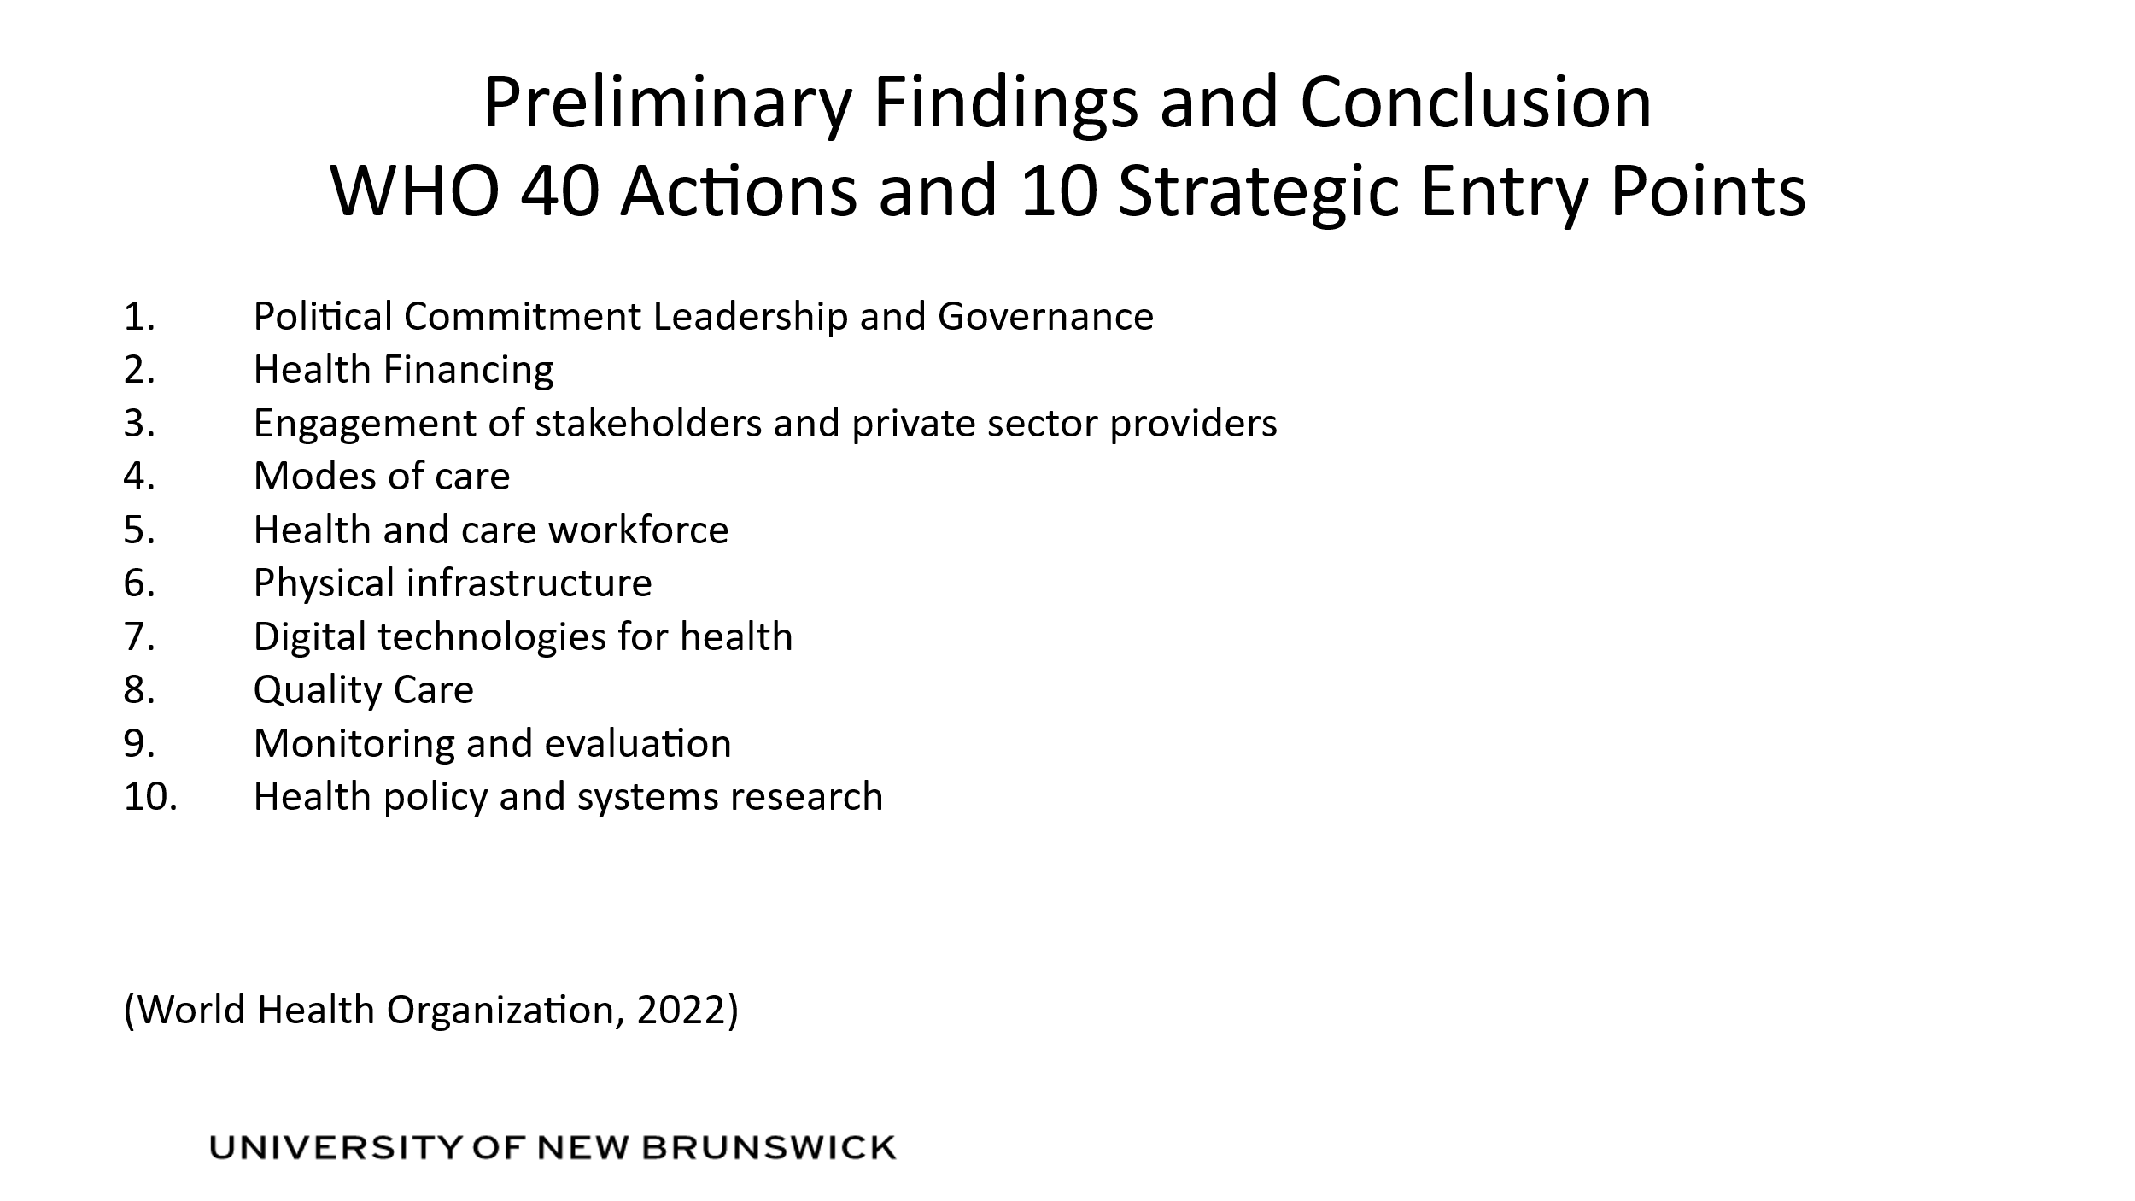
13. Preliminary Findings and Conclusion WHO 40 Actions and 10 Strategic Entry Points
- Political Commitment Leadership and Governance
- Health Financing
- Engagement of stakeholders and private sector providers
- Modes of care
- Health and care workforce
- Physical infrastructure
- Digital technologies for health
- Quality Care
- Monitoring and evaluation
- Health policy and systems research
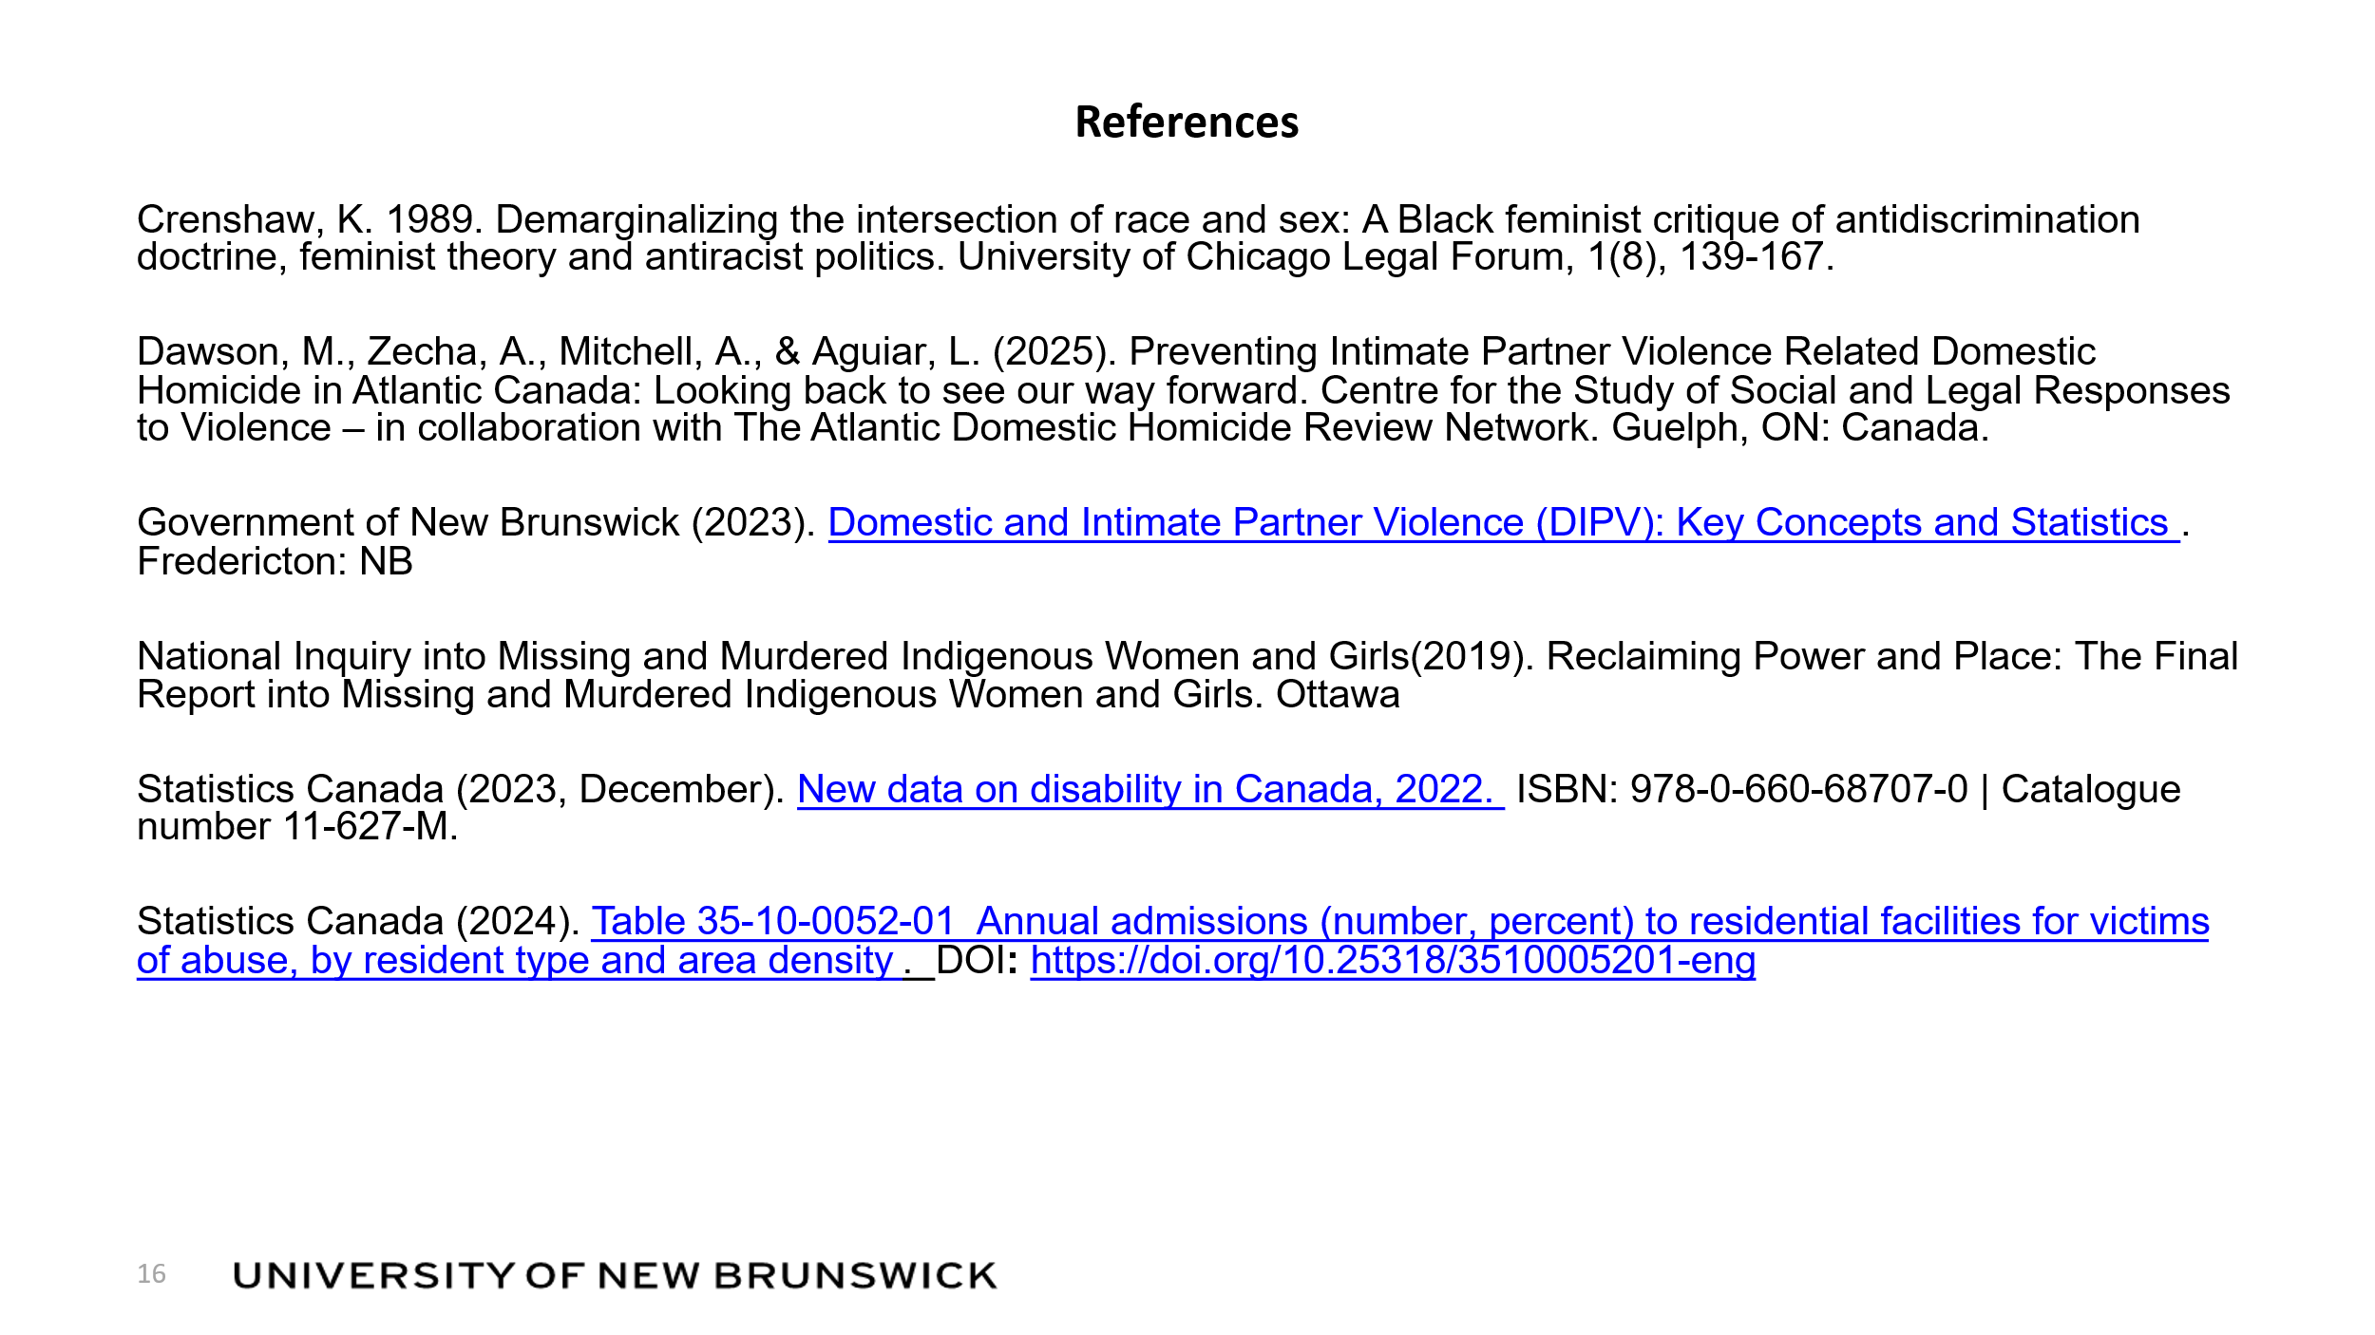
13. References
Crenshaw, K. 1989. Demarginalizing the intersection of race and sex: A Black feminist critique of antidiscrimination doctrine, feminist theory and antiracist politics. University of Chicago Legal Forum, 1(8), 139-167.
Dawson, M., Zecha, A., Mitchell, A., & Aguiar, L. (2025). Preventing Intimate Partner Violence Related Domestic Homicide in Atlantic Canada: Looking back to see our way forward. Centre for the Study of Social and Legal Responses to Violence – in collaboration with The Atlantic Domestic Homicide Review Network. Guelph, ON: Canada.
Government of New Brunswick (2023). Domestic and Intimate Partner Violence (DIPV): Key Concepts and Statistics. Fredericton: NB
National Inquiry into Missing and Murdered Indigenous Women and Girls(2019). Reclaiming Power and Place: The Final Report into Missing and Murdered Indigenous Women and Girls. Ottawa
Statistics Canada (2023, December). New data on disability in Canada, 2022. ISBN: 978-0-660-68707-0 | Catalogue number 11-627-M.
Statistics Canada (2024). Table 35-10-0052-01 Annual admissions (number, percent) to residential facilities for victims of abuse, by resident type and area density. DOI: https://doi.org/10.25318/3510005201-eng

